User Manual

SciQuizzy

Table of Contents

|  |  |  |
| --- | --- | --- |
| Sl. No | Topic | Page. no |
| 1 | Introduction   * Who can benefit from SciQuizzy * Key features | 3 |
| 2 | Technical Specifications | 3 |
| 3 | Requirements   * PC Requirements * Supported web browsers | 4 |
| 5 | Guidelines on how to use SciQuizzy | 5 |
| 6 | Getting started   * Installation * Sign in and sign up * Attempting the quiz | 5 |
| 7 | Frequently Asked Questions | 11 |

1. Introduction

SciQuizzy is a web app that facilitates users to attend instant time-bound quizzes based on scientific concepts, theories and scientific phenomena. It generates intriguing quizzes as many times as the user wants with different non-repetitive questions that can test the users’ insight into scientific facts.

1.1. Who can benefit from SciQuizzy:

* Students attending schools and colleges
* Quiz masters who wish to collect questions for conducting Science quizzes
* Science enthusiasts
* Teachers and Professors

1.2. Key features:

* User account creation and login system
* User friendly and intuitive functionalities
* Instant quizzes with a time limit for attending each question
* Evaluation of answers immediately after attempting every question
* Display of correct answers in case the answer chosen by user is wrong
* Scoring system with leaderboard

2. Technical Specifications

Programming languages used: C++, JavaScript, HTML, CSS

Tech stacks and libraries used:

|  |  |  |
| --- | --- | --- |
| Programming language | Library/ Tech stack | Functionality |
| C++ | String  Sstream  Vector  Fstream | To handle strings which are sequence of characters  Helps in handling string as if it were a stream  Used to implement the sequential container vector  Used to perform read and write on files |
| JavaScript | Node.js  Express.js  Compile-run  Cors  Body-parser  Axios  Dotenv | It is an open source environment that can use JavaScript on server  Web application framework for Node.js that provides robust features for web applications  Used to compile C++ programs in Node.js applications  Cross Origin Resource Sharing. Facilitates resource sharing across servers  HTTP request body that accesses underlying information in a URL  HTTP library that interacts with API (Application Programming Interface) services  Loads environment variables from .env file into process.env |

3. Requirements

A stable internet connection and the presence of git (Version control system) are inevitable to install and use the web app

3.1. PC requirements:

* Windows 10 OS or greater
* 4 GB RAM or greater
* 10 GB free space or greater
* Compatible in all Linux environments

3.2. Supported web browsers:

* Chrome - versions 63+
* Firefox - versions 58+
* Opera – versions 50+
* Edge - versions 13+
* Safari – versions 9+

5. Guidelines on how to use SciQuizzy

Once the required packages are installed, the web app is ready to be used

* Ensure a stable internet connection
* Install software according to installation instructions
* Use anti-malware software with frequent updates

6. Getting started

6.1. Installation

6.1.1. Setting up the repository

1. Fork the github repository containing the code base. The repository can be found [here](https://github.com/Nanthana2003/SE.git).
2. Create a folder in the local machine for the web app
3. Convert it into a git repository by typing the following command in the terminal

>> git init

1. Clone the repository forked out by typing the command

>> git clone <repository link>

1. Head into the folder SE by typing the following command in the terminal

>> cd SE

6.1.2. Setting up the backend

1. Head to the folder containing the backend by typing the command

>> cd Backend

1. Create a .env file in it similar to the .env.example file
2. Install Node Package Manager by typing the command

>> npm init

1. Install the required dependencies by typing the following command in the terminal

>> npm install

1. Run the server by typing the command

>> npm run dev

6.1.3. Setting up the frontend

1. After configuring the backend, head to the folder containing the frontend by using the command

>> cd ../Frontend

1. Run the login.html file using any of the browsers mentioned above.

6.2. Sign in and Sign up

1. New users have to sign up by filling in their email address, username and password



1. If the email id that was entered had already been used by another user, a message will be displayed prompting the user to enter new details again.

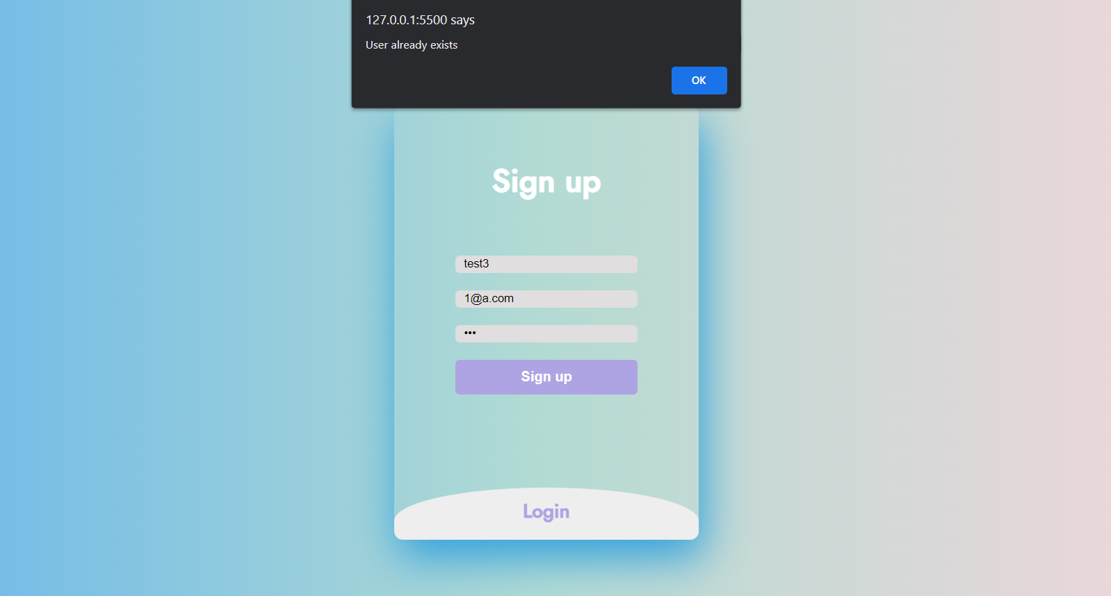

1. If any of the input fields are left empty, a message will be displayed prompting the user to enter all the details again.

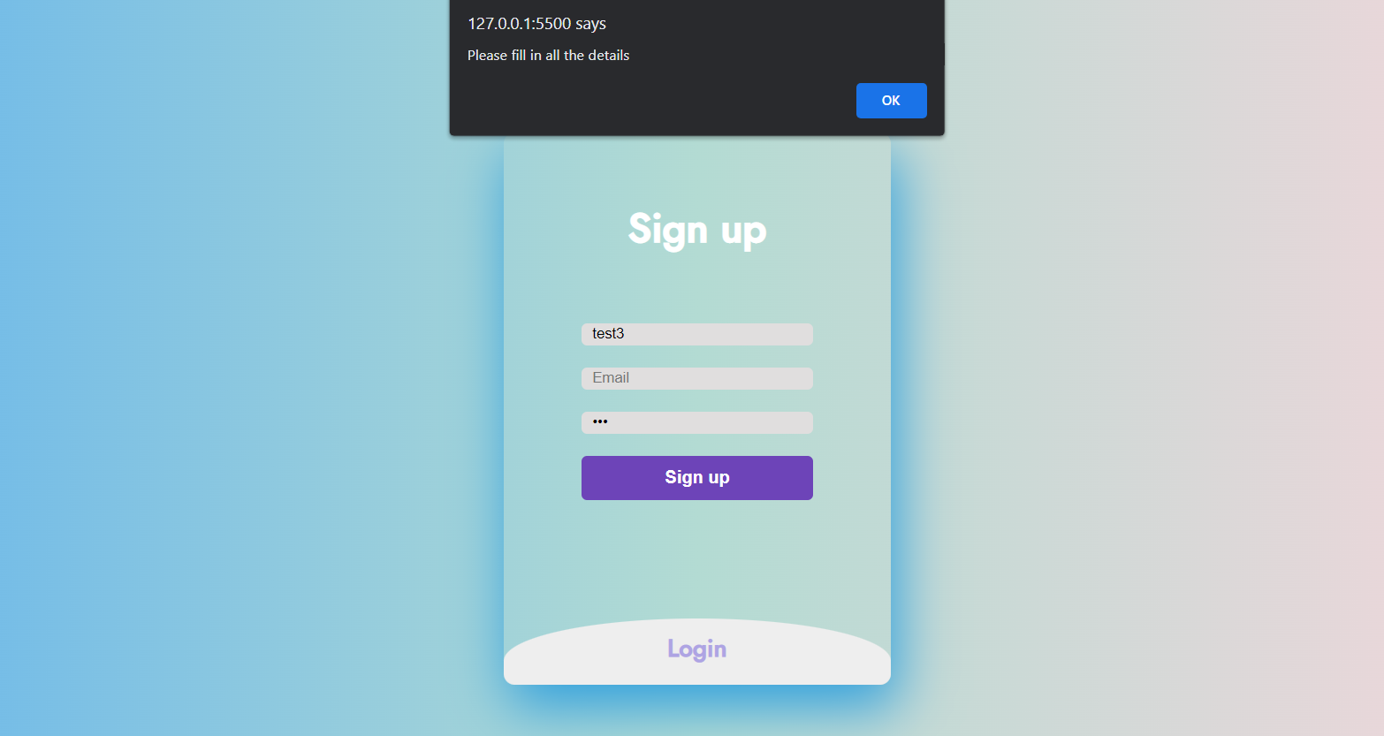

1. After signing up, enter the email id and password in the login page to attempt the quiz. Users who already signed up can skip step I to III.



1. If incorrect password is entered or if the email id used for signing in is not registered, appropriate messages will be displayed.

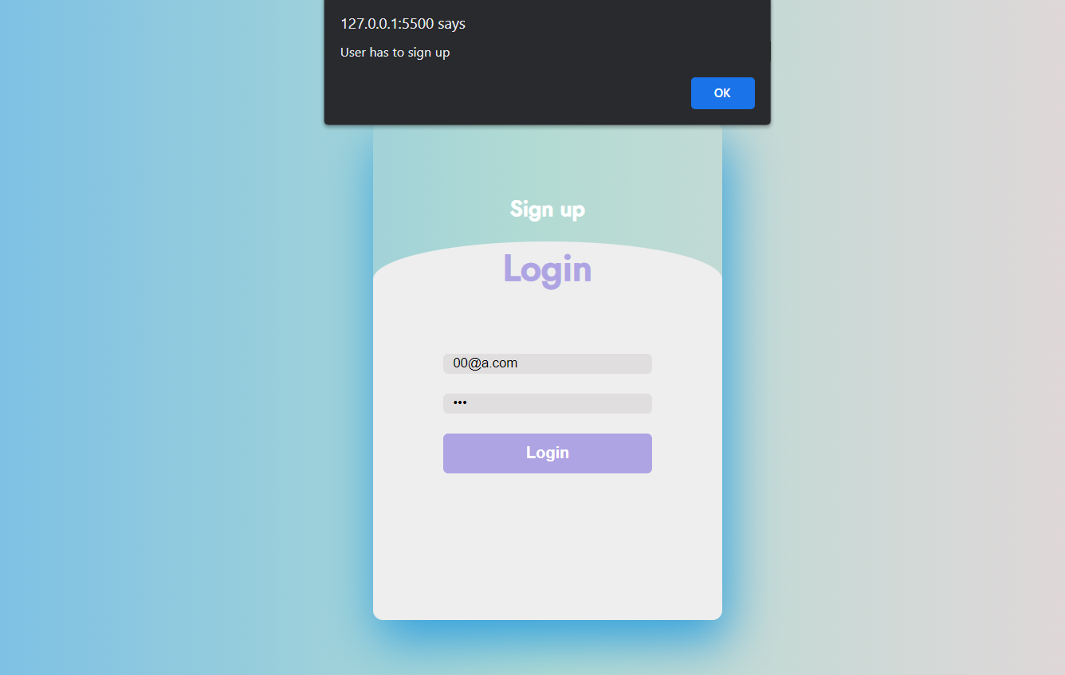

1. On entering correct details users will be redirected to the page containing the main quiz.

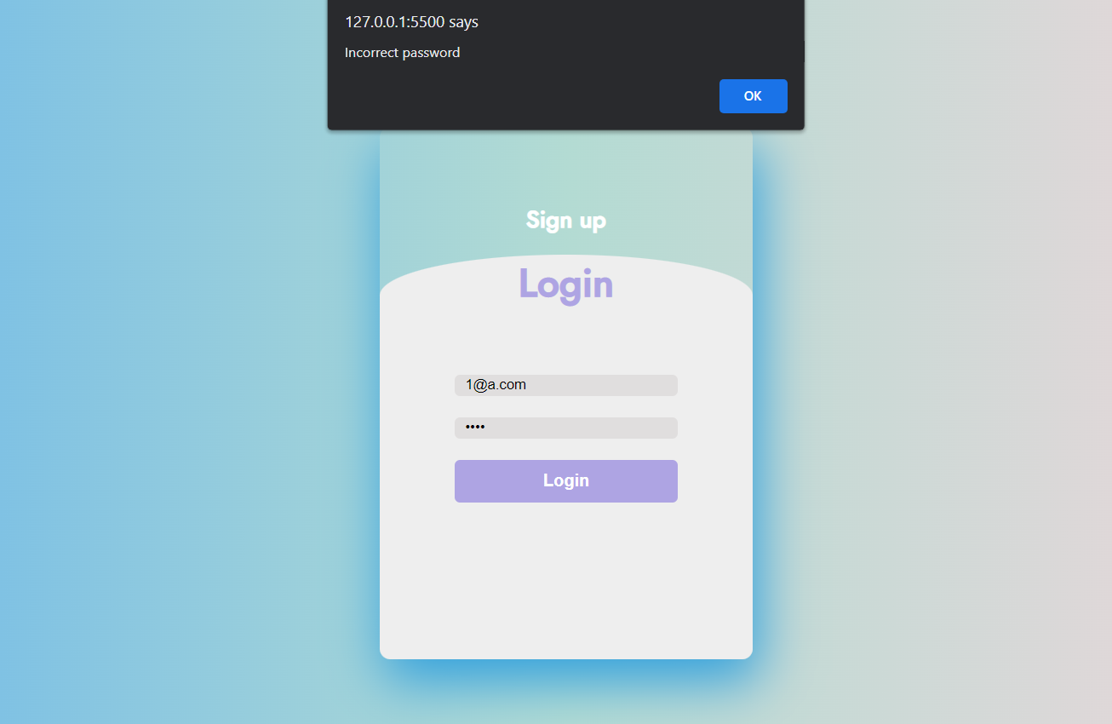

6.3. Attempting the quiz

1. The progress bar on top indicates the amount of time left to attempt a question. Seven seconds will be provided to attempt each question. Each quiz will contain a total of 10 questions.

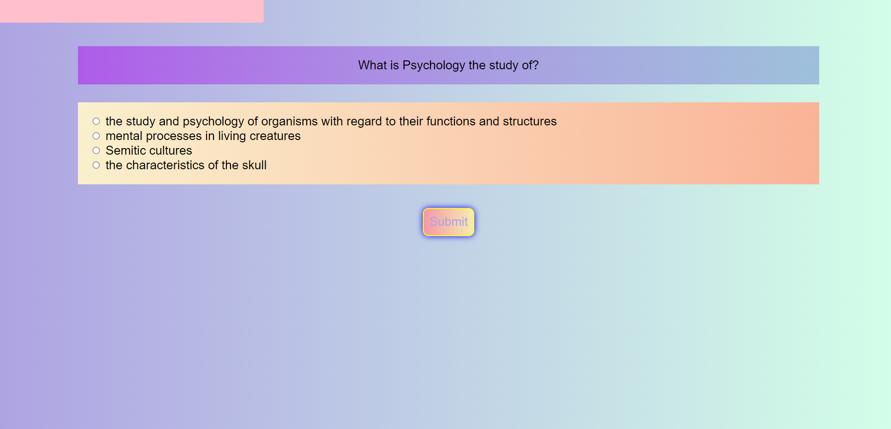

1. After choosing the option press on “Submit” button to verify the answer.
2. If it is correct, message will be displayed in a green box.

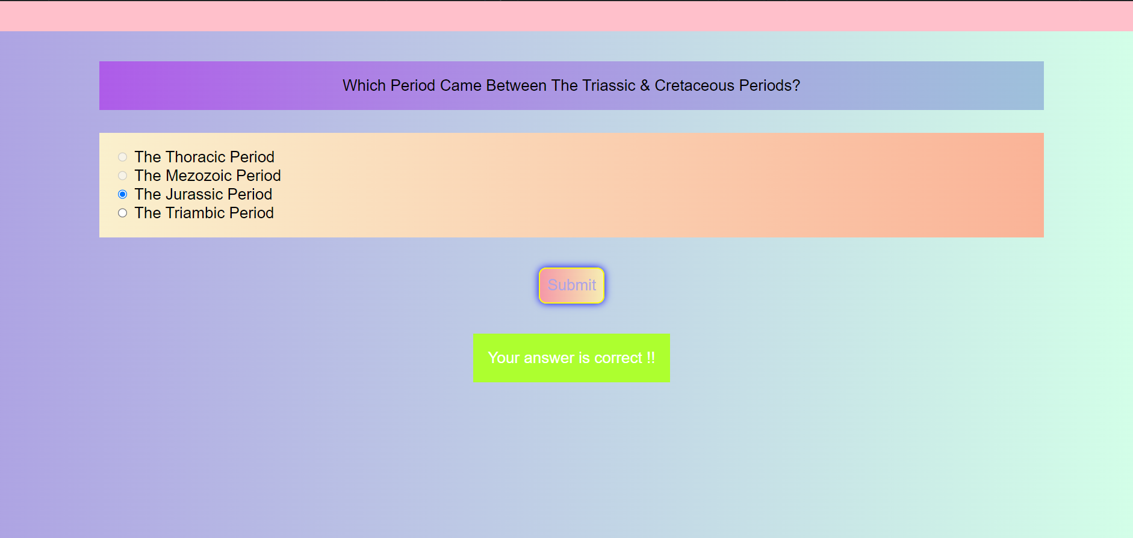

1. If it is incorrect, the message will be display in a red box along with the correct answer.

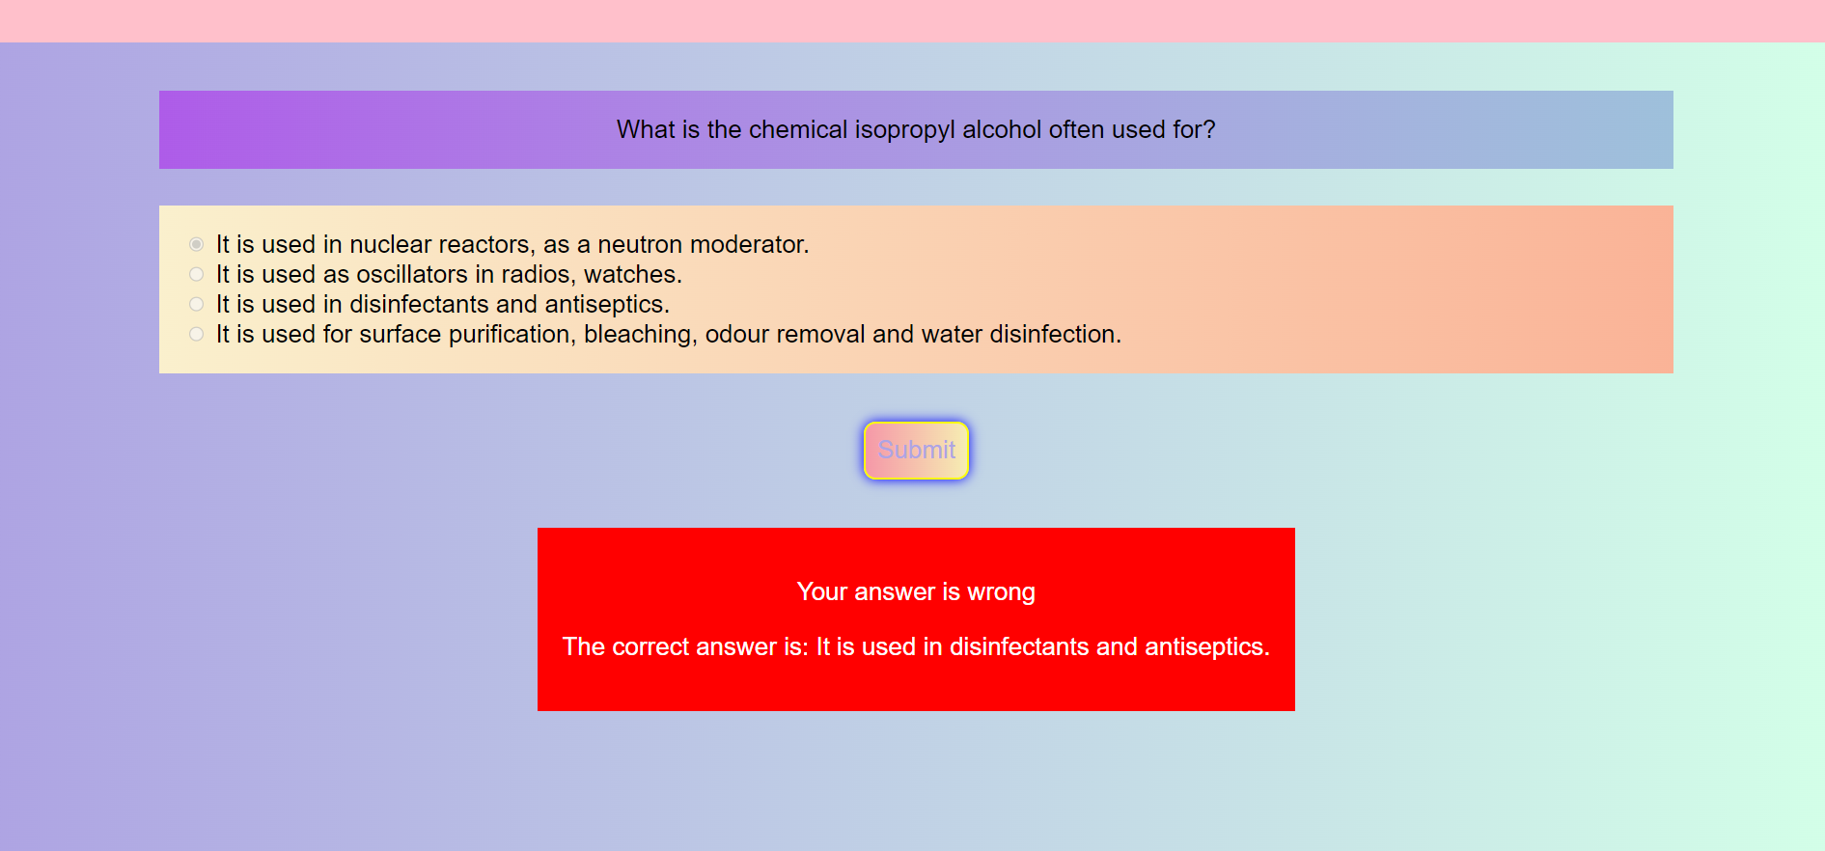

1. Each question carries 10 points which will be credited to the user if the option chosen by him/her is correct. If the question is unanswered or wrong option is chosen, the points won’t be credited.
2. After all the questions are completed, the score obtained by the user will be displayed along with a button that take the user to the leaderboard.



1. The leaderboard shows the highest score obtained by the users who had used SciQuizzy until then.
2. It also contains options to logout of SciQuizzy and to take another quiz.

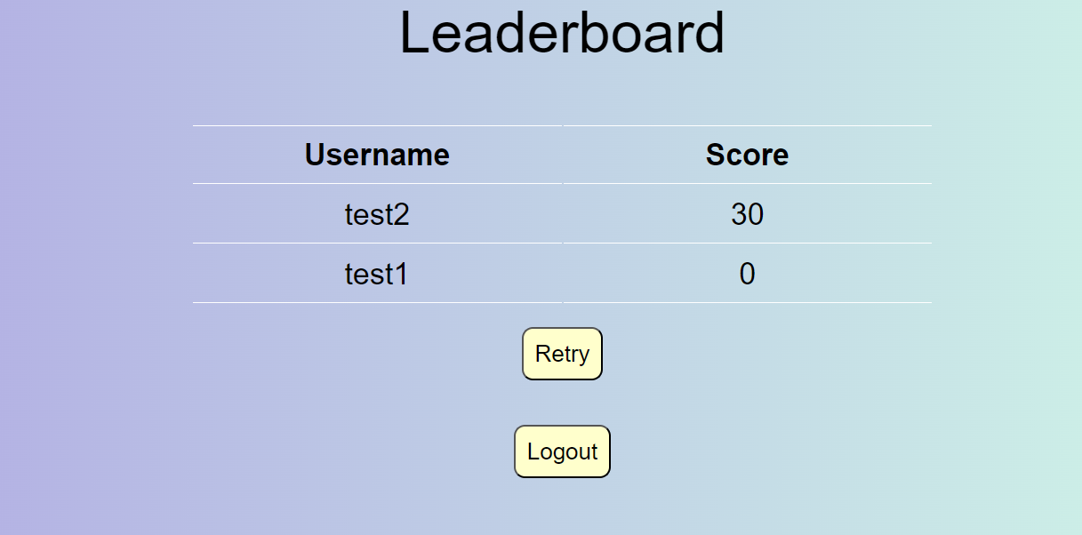

7. Frequently Asked Questions

1. Should I pay to attempt quizzes?

Ans: No, SciQuizzy is free. Users can attempt as many quizzes as they want for free.

1. Can I change the category of questions?

Ans: No, SciQuizzy is meant for enhancing scientific knowledge by attempting Science quizzes